 | CAMECA IMS 7f and 4f-E7  Accel-decel system for the duoplasmatron  Ref 00 45 633 918 – type 108 – Indice A-
0000.doc
Index

Contents

1. Introduction 2
2. Basic principle of the accel-decel system 2
3. Accel-Decel system analytical features. 4
4. Hardware configuration 4
5. Alignment procedures 5
5.1 High primary extraction voltage ( Duo_HV > 2 kV) 6
5.2 Low primary extraction voltage (Duo_HV < 2 kV) 7
5.3 Instrument setting file download 7
6. Annex 1. Application examples 8
7. Annex 2. Primary beam incident angle 9

Introduction

This user’s guide describes the main functions and the operating instructions for the Accel-Decel system developed for the duoplasmatron source of the CAMECA IMS 7f series.
This document is divided in 6 parts providing information on:
- Basic principle of the Accel-Decel system
- Main analytical performances
- Hardware configuration
- Alignment procedure
- Annex 1. Application examples
- Annex 2. Incidence angle

Contents ↑

Basic principle of the accel-decel system
For positive secondary ions analysis on magnetic sector SIMS instruments, the sample (brought to a high potential in order to collect the secondary ions with a very high efficiency) acts as a deceleration electrode for the primary beam ions. Thus theoretically, low impact energy primary ions can be reached while keeping a rather high extraction voltage on the Duoplasmatron (DP) source and decelerating primary ions just before reaching the sample surface.
Practically, due to the oblique incidence of the primary column, high amplitude deceleration effects yield to very large incidence angles (beyond 70° relative to normal) of the primary beam. These large incidence angles make focusing the primary beam difficult. Moreover, large incidence angles are not suitable for sputtering silicon with oxygen beam because of ripple formation which deteriorates depth resolution. By reducing the secondary extraction voltage primary ions undergo low amplitude deceleration effects and incidence angles can be maintained in the range of 40 to 60°. The reduction of the secondary extraction voltage leads to a reduction of both the mass spectrometer transmission (the transmission varies as the extraction voltage) and the electron multiplier detection efficiency. The latter effect can be cancelled by using the accessory “post-acceleration for the electron multiplier”.
For a standard CAMECA IMS 7f the main limiting factor in routinely operating mode at sub-keV impact energies (< 1keV) was determined by the performance of the Duoplasmatron source itself. Actually O₂⁺ primary beam with impact energy of 500eV and an incidence angle of 44° is obtained by setting the DP source at 1kV and the secondary extraction voltage at +500V. At a 1kV DP extraction voltage, space charge effects reduce the source brightness and the primary beam density is no longer high enough to maintain sputter rates at levels compatible with high throughput analyses.
This limitation has now been overcome by the development of a new extraction system for the Duoplasmatron source, running in acceleration/deceleration mode. It consists in maintaining an extraction voltage on the Duoplasmatron source high enough to avoid space charge effects and decelerating primary ions at the entrance of the primary column in order to reach the target with low impact energy.
The Accel-Decel system developed for the Duoplasmatron source of the IMS 7f is represented in the Fig. 1. The DP source itself is not modified, but the formally grounded extraction electrode is electrically isolated, and is biased at a negative potential. An Einzel lens (L1) is also added, downstream, between the DP source and the primary beam mass filter (PBMF). As shown in Fig. 1, primary ions are accelerated between the DP source anode (A) and the extraction electrode (EE), and then decelerated between (EE) and the lens (L1). Finally, they reach the sample surface with a net impact energy determined by the difference between source and sample potentials. Lens (L1) focuses the beam in order to match the DP source emittance with acceptance of the PBMF and to compensate the focalization effect of the extraction electrode (EE) when it is biased.
Figure 1 : Schematic representation of the Accel-Decel system.
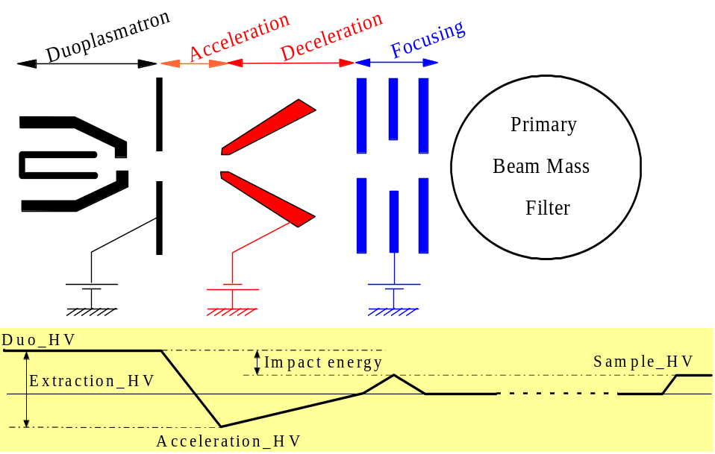
(EE)
(L1)
(A)

The variations of the maximum beam intensity (measured at the end of the primary column) as a function of the DP source voltage, with and without the Accel-Decel system, are plotted in Fig. 2. The DP source voltage was varied over the range 1.5-10 kV. The Cameca IMS 7f primary column was equipped with an opening aperture (L4 aperture) of 400µm. These data demonstrate that over the entire investigated range, the Accel-Decel system provides higher beam intensities.
Figure 2 : Maximum beam intensity as a function of the duoplasmatron source voltage (Duo_HV),
with and without the Accel-Decel system.
0
5
10
DP_HV (kV)
0
1000
2000
3000
Ip_max (nA)
Maximum intensity = f(Duoplasmatron extraction voltage)
Accel_Decel
Standard IMS 7f
L4 aperture = 400 µm
1
2
3
0
200
400
600

The intensity gain increases from 1.4 up to 2.5 when the DP source voltage decreases from 10 kV to 1.5 kV. It must be pointed out that the (L1) effect (beam emittance matching) is the predominant source of intensity gain over the range 2-10 kV, whereas the acceleration/deceleration mode (bias of EE) becomes significantly efficient below 2 kV. The straight lines in plot represent the expected linear variation for an ideal ion optical system (perfect source emittance matching and no space charge effects). The IMS 7f primary column equipped with the Accel-Decel system approaches such a linear behavior.

Accel-Decel system analytical features.
- 500eV impact energy, 44° incidence angle.
- Beam of 50 µm in diameter (5-95% definition) carries 25nA.
- Sputter rate >2 nm/min in Si with O2 flooding.
- Boron detection limit < 3E16 at/cm3 for an analyzed area of 33um (for an instrument equipped with the EM post-acceleration system).

Hardware configuration
Figure 3 shows the Accel-Decel system. The duoplasmatron flange with the acceleration electrode can be observed on the foreground of the photo.
Figure 3 : General view of the Accel-Decel system
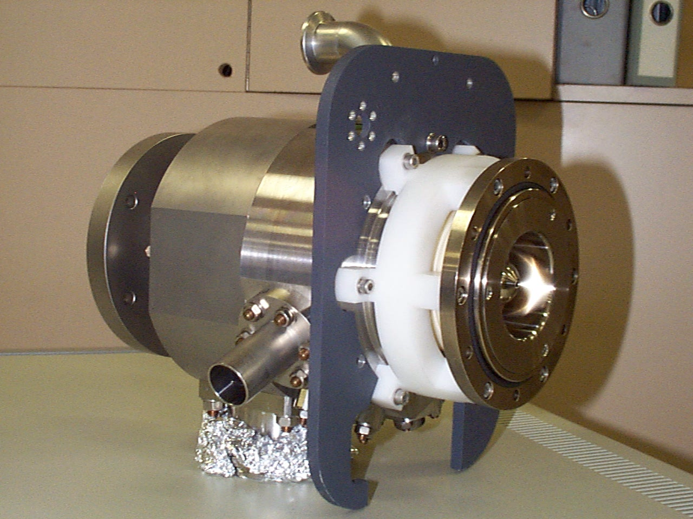
Duoplasmatron flange
Acceleration electrode
PBMF flange
Lens #1 housing

The parameters of the Accel-Decel system are adjusted through the CAMECA IMS 7f Tuning synoptic panel.
Figure 4 : control of the Accel-Decel parameters
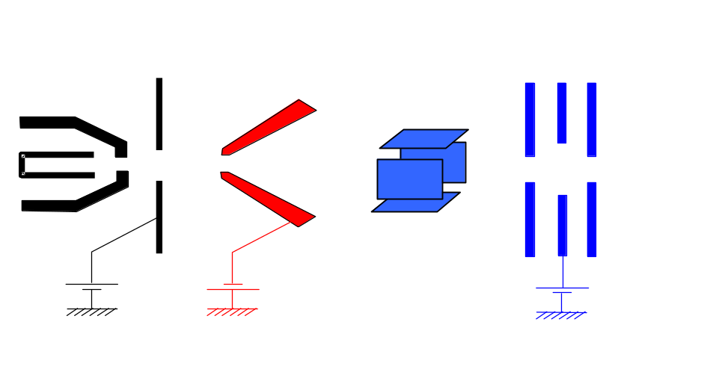
L1 DUO HV
Accel HV
Dprim1_X and Dprim1_Y
Duo HV

Note: that the Accel electrode and the L1 lens have always opposite polarity.

Alignment procedures
In this section we describe the alignment procedure of the CAMECA IMS 7F primary column when the duoplasmatron is equipped with the Accel-Decel system. Two different modes are distinguished: high primary extraction voltage (> 2kV) and low extraction voltage < 2kV.
In the hereunder sections the labels of the lenses of the primary column are:
- L1 Duo (Accel-Decel lens)
- L2 (lens just after the PBMF)
- L3 (lens after the mass resolution aperture of the primary column)
- L4 (last lens of the primary column)

High primary extraction voltage ( Duo_HV > 2 kV)
Starting conditions:
- Duo_HV = 10 kV
- Select the largest L4 aperture
- Set L1 DUO = 95% of Source_HV, L2 = 1600 digits, L3 = 1700 digits, L4 = 30000 digits
- Set Accel_HV = 0
- Set Coil ~ 300 digits. Oxygen pressure in the duoplasmatron source same as without the Accel-Decel.
- Set prim1_X and Dprim1_Y to 0
- Set the other deflectors at the values used without the Accel-Decel system.
Alignment procedure:
- Adjust L1, L2 and L3 and PBMF in order to maximize the primary beam intensity.
- Get a secondary ion image on the micro-channel plate.
- Increase L3 to get a small beam and wobble L4 in order to center the L4 aperture on the optical axis of L4 (see the general IMS 7f user’s guide).
- Go back to the maximum beam intensity and wobble L3 in order to center the primary beam in this lens by means of Dprim3_X and Dprim3_Y (see the general IMS 7f user’s guide)
- Go back to the maximum beam intensity and wobble L2 in order to center the primary beam in this lens by means of PBMF and Dprim2_Y (see the general IMS 7f user’s guide)
- Go back to the maximum beam intensity and wobble L1 in order to center the primary beam in this lens by means of Dprim1_X and Dprim1_Y
- Go back and forth carrying on the centering procedure for these four lenses until reaching a correct alignment for the four stages of the primary column.
- Adjust the primary beam size at the desired value by adjusting L2, L3 and L4. It is recommended to keep L1 close to approximately 95% for a given Souce_HV.

Low primary extraction voltage (Duo_HV < 2 kV)

Starting conditions:
- Duo_HV = 10 kV
- Maximize the primary beam current with L1, L2 and L3 and get a secondary ion image on the micro-channel plate.
- Adjust the secondary accelerating voltage to a value compatible with the desired impact energy and incident angle (see §7 Annex 2 in this user’s guide). Align the mass spectrometer following the procedure described in the general IMS 7f user’s guide (for a secondary accelerating voltage lower < 2 kV it is worth setting the immersion lens in the accelerating mode. Note that when the secondary extraction voltage is changed, it is not required to go through the entire primary column alignment given in § 5.1 to get back a well focused primary beam. Only the Beam Position deflector, the L4 voltage, and the L4 stigmator have to be re-tuned.
- Decrease the Duo_Source_HV. It is strongly recommended to go step by step from high to low Duo_Source_HV values. For instance, starting from 10 kV to go to 2 kV, it is worth making steps at 6 and 3 kV.
- At every step above 2 kV apply the alignment procedure given in § 5.1.
Alignment procedure below 2 kV:
- Adjust L1, L2 and L3 and PBMF in order to maximize the primary beam intensity.
- Once the primary column has been aligned following the procedure given in §5.1, go back to the maximum beam intensity.
- Increase Accel_HV up to 200 V (note that it is negative for O2⁺ primary ions). Maximize the primary beam intensity first by re-center the beam with Dprim1_X and Dprim1_Y and then by tuning L1, L2 and L3. Go back and forth between deflector and lenses to maximize the beam intensity. It might worth reducing the Duo_coil value to increase the beam intensity. Generally speaking when the Duo_coil decrease L1_HV must be also decreased in order to maximize the beam intensity.
- Increase Accel_HV by steps of 50 digits, maximize the beam intensity as just aforementioned, as long as a beam density improvement can be observed
- Adjust the primary beam size at the desired value by adjusting L2, L3 and L4. It is recommended to keep L1 at the value giving the maximum beam intensity.

Instrument setting file download
When restarting the instrument with the Accel-Decel system setting, if the primary beam intensity is not as high as it was for a given setting of the primary column, it is recommended first of all to check the centering of the primary beam in the first part of the primary column by using Dprim1_X, Dprim1_Y and the PBMF. In most of the case it will be enough to recover the correct setting of the primary column.

Annex 1. Application examples
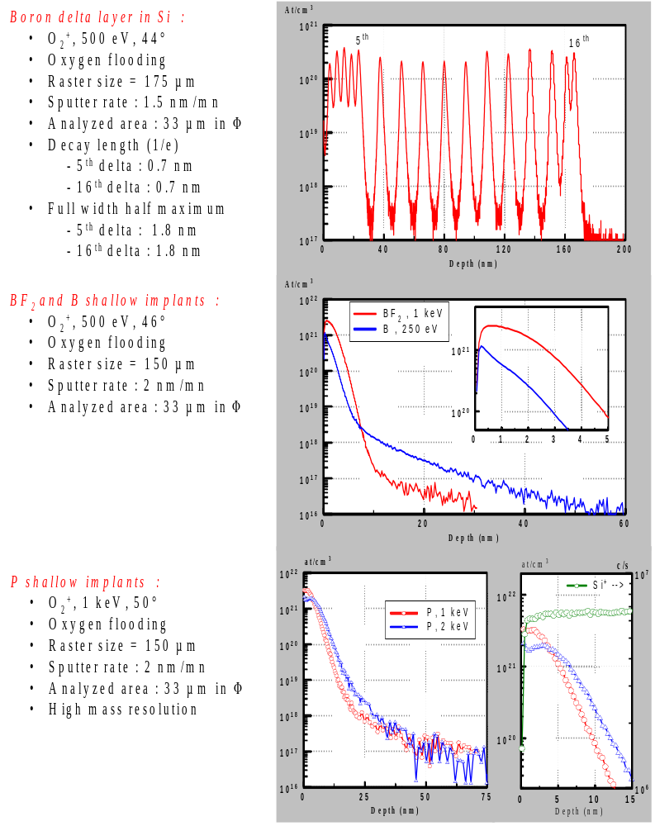

Annex 2. Primary beam incident angle
Due to the
geometry
of the
primary column
and
the
secondary
ions extraction system of
the CAMECA IMS 7f (
Fig
. 1), the
primary
beam
incidence angle
can be computed
, in
first
approximation
from
the
relationship
:
where Vs and Vp
stands for the
secondary
and primary accelerating
voltage,
respectively
.
It
must
be noticed that
the
deflector
of the
primary column used
to
bring
back
the
primary
spot
onto
the axis of the mass
(
)
sin
sin
/
θ
α
=
=
°
−
30
1
V
V
s
p
Accelerating voltage
θ
θ
'
Vp (kV)
Vs (kV)
α
(= 30°)
α
'
+ 8
+ 5
54.7
51.8
+ 5
+ 3
52.2
49.7
+ 3
+ 2
60.0
55.9
+ 1.15
+ 0.9
90
81.1
+ 1
- 0.6
23.3
23.7
Table 1:
Comparison between

θ
and
θ
' values for
different Vs and Vp
configurations.
spectrometer makes
the
primary beam
entering
in the
secondary
ion extraction
space with
an angle
α
'
different from
α(=30°)
. A more
accurate
computation of
incidence angle values
can be performed
by
taking into account this effect
. Values for
θ
and

θ
' for
different Vs and Vp
configurations are
reported
in Table 1.
The
diagram plotted
in
Fig
.1 shows the
variation of
θ
' as a
function
of the
primary
ion source extraction voltage for
different
positive
secondary
voltages.
The CAMECA IMS 7f
offers
a
rather
large
flexibility
for the incident angle
setting at
different
impact
energies
(Table 2).
Fig
.1:
Primary column and secondary
ions
extraction system configuration of the
CAMECA IMS 7f.
α
'
θ
α
Beam position deflector
θ
'
Sample surface
Immersion lens
Secondary ion optics axis
Primary column axis
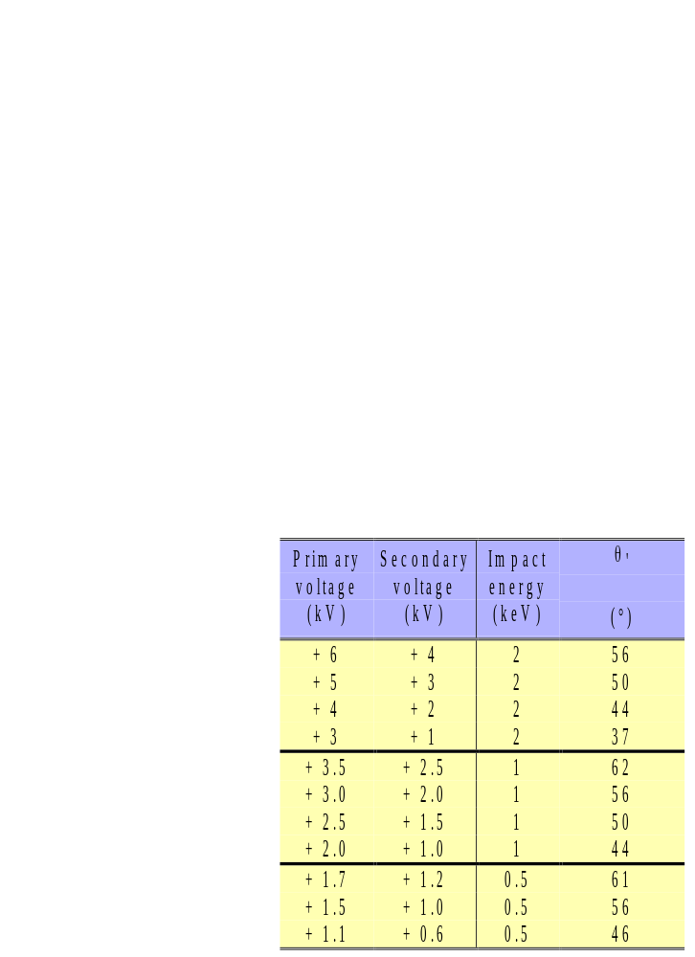
Contents ↑

